# Extensible Web-Based Workflow Management System

Table of Contents

Extensible Web-Based Workflow Management System 1

1. Description 1

2. PURPOSE 1

3. FEATURES 1

4. TECHNOLOGIES USED 2

5. INSTALLATION PROCESS 2

5.1 INSTRUCTIONS ON HOW TO ACCESS AND STORE THE FOLDER PROVIDED ON GITHUB TO THE CORRECT DIRECTORY ON YOUR LOCAL COMPUTER. 2

6. Dependencies and extensions 3

7. IMAGES OF THE SOFTWARE 4

7.1 Image of the Database 4

7.2 XAMP Images 6

## Description

I created an extensible web-based workflow management system.

## PURPOSE

The software helps users upload excel documents into a web-based system. The software then renders the excel

Documents into a graphical visualisations which produces more efficient,

Faster reporting and promotes safer data analysis limiting human error when compiling data analysis reports.

## FEATURES

The Software collects the user’s first name, last name and date of birth through a basic HTML form.

It has an upload button where the user can upload excel financial spreadsheets.

The software then processes the data and renders the data into

A graph.

The software interface is very easy for the user to understand and interact with.

The graphical representation of the data is easily accessible on the front page.

 The user does not need to do any configuration, the operations are all running in the back end,

Through extensible third party integration (Microsoft excel) that feel indistinguishable from the native

Functionality.

## TECHNOLOGIES USED

The software is created in visual studio code and runs on xampp server and apache.

 It’s running on a local host. The software is able to upload excel files and has human input

Through an html form where the user inserts first name, last name and date of birth.

 The excel document is a has financials for a year (income and expenses for 12 months)

Once the user uploads the excel file is appears as a graph.

This software is extensible as it can be upgraded to add new functionalities like,

 Loading the data generated from MySQL workbench (DATABASE) to create more focused

And direct offerings to clients based on their data, it can be connected to

Banking applications that help people track their spending, it can help organisations

Allocate their budget wisely based on analysing the data

This software was created using PHP, which is a programming language

That is used to develop web-based applications and work management systems.

The PHP language then connects to XAMPP- XAMPP is a web server that allows

 Programmers to write and test their code on a local webserver

## 5. INSTALLATION PROCESS

1. DOWNLOAD AND INSTALL XAMPP Control panel v3.3.0 ONTO YOUR COMPUTER

2. FOLLOW THE XAMPP INSTALLATION INSTRUCTIONS TILL YOU HAVE COMPLETED THE INSTALLATION

3. INSTALL VISUAL STUDIO CODE ONTO YOUR COMPUTER

4. OPEN XAMPP CONTROL PANEL (xampp is local development environment which includes Apache, PHP, MySQL)

5. CLICK START ON APACHE and CLICK START ON MYSQL - This enables the software to run on the web (Google chrome)

NB! Please make sure no firewall is blocking access to the web server.

### 5.1 INSTRUCTIONS ON HOW TO ACCESS AND STORE THE FOLDER PROVIDED ON GITHUB TO THE CORRECT DIRECTORY ON YOUR LOCAL COMPUTER.

1. CLICK ON THIS PC

2. THEN CLICK ON LOCAL DISK(C :)

3. CLICK ON xampp

4. CLICK htdocs

5. DRAG THE FOLDER CALLED APPLICATIONS (PROVIDED ONILNE IN GITHUB) INTO THIS htdocs FOLDER

6. ONCE YOU HAVE COPIED THE APPLICATION FOLDER TO htdocs, OPEN THE FOLDER CALLED APPLICATIONS AND

7. RIGHT CLICK ON THE index.php file

8. Click open with Visual Studio Code

9. Once the file is open in visual studio code

Press F5 to run the source code.

10. Open google chrome browser and type localhost/application or Localhost: 80/application

NB! Please remember that the software will only run if you have started your xampp Apache and MySQL server

## Dependencies and extensions

In order for visual Studio code to understand my language and output i installed

* PHP library (PHpSpreadsheet)
* java script
* NodeJS
* css namespace
* flask framework
* chartjs library
* Composer installed

## IMAGES OF THE SOFTWARE

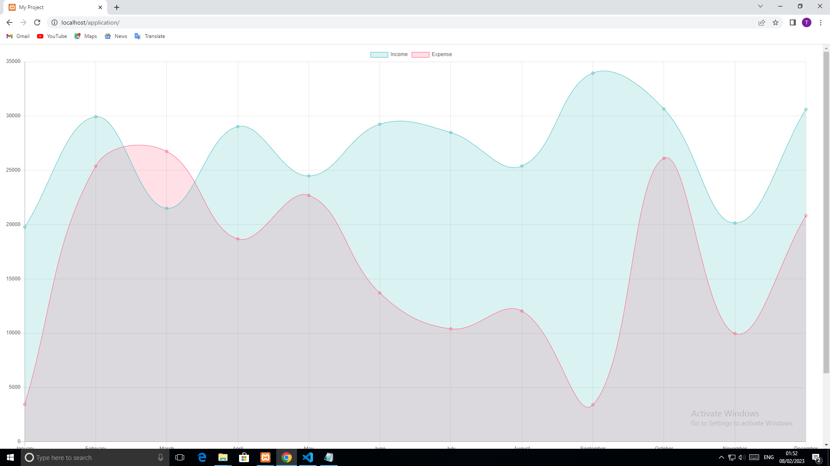

### 7.1 Image of the Database

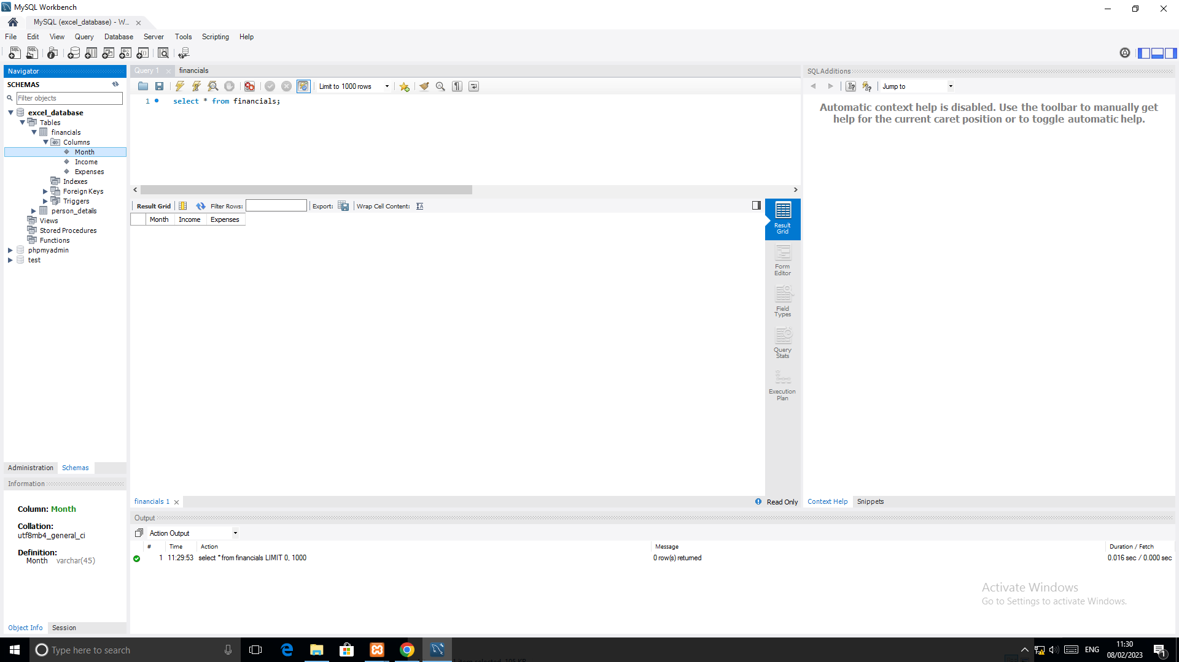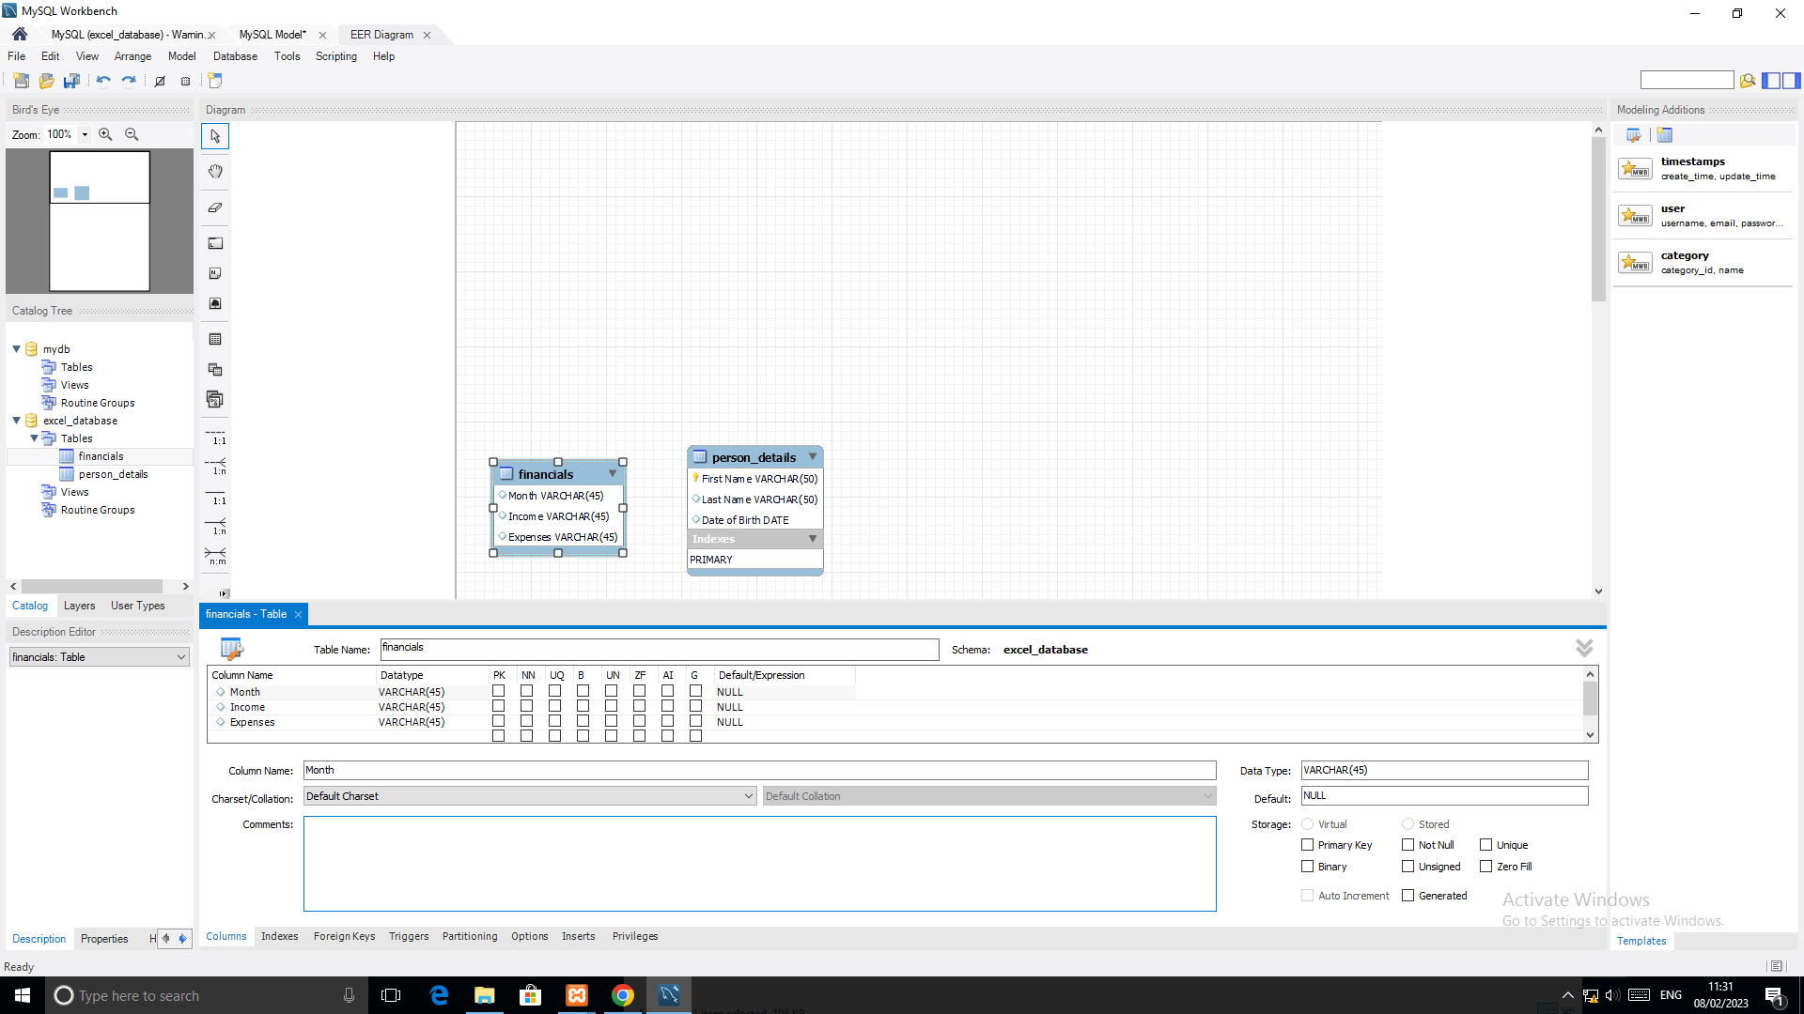

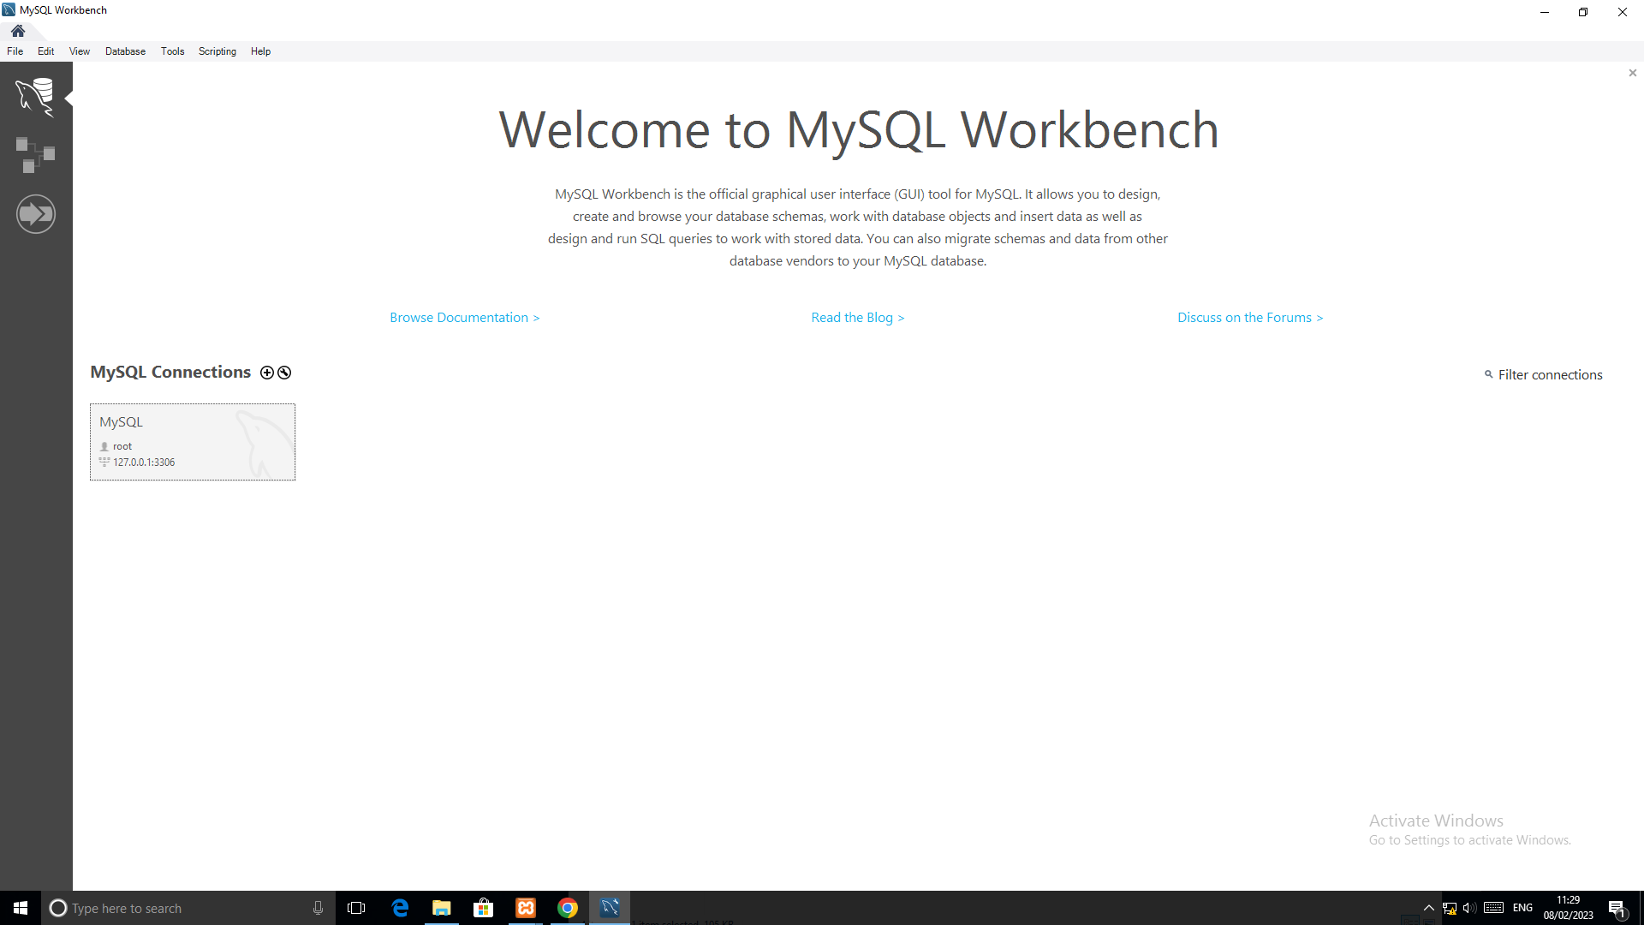

### 7.2 XAMP Images

